

Spectral Forest
  - tEEm Radiance
Benjamin Reed, Hayden O’Reilly, Manolo Ortiz | Project Design Procedures
October 13, 2023

Table of Contents
Executive Summary 2
Statement of Needs 3
marketing requirements 3
objective tree 3
pairwise comparisons 4
expectations 5
Statement of Objectives 6
System Requirements 6
Technical and functional requirements 6
Hardware, software, and performance requirements 7
Engineering trade-off matrix 8
Engineering-marketing tradeoff matrix 9
Benchmark comparing existing options 10
House-of-quality 11

Executive Summary

The goal of the Spectral Forest project is to develop a spectrometer, capable of hyperspectral imaging in the range of 350 nm to 1000nm, which can be deployable remotely, outdoors, and for at least five days between charges. The box will be purpose built to deliver an ideal response curve along the intended spectrum. Initially, the box will gather light samples from the forest floor where we can verify its operation. The spectrometer will also eventually be deployed on Unmanned Aerial Vehicles (UAVs), or ground-based rovers. Design aspects are being incorporated to accommodate a variety of potential applications and some modular attachments like a solar panel and Wi-Fi antenna. These can be removed or attached based on the application utilized. For example, the solar panel and Wi-Fi antenna can be removed for use on a UAV.
Data collected will include information on light intensity and wavelength, but we will also program and equip the unit to collect temperature, humidity, barometric pressure, as well as the angle relative to the horizon. The data will be collected in an internal flash memory and accessible via USB 2.0 or via Wi-Fi. This data will be used in analyzing the forest spectra. The wavelengths of light that are reflected or absorbed by the forest canopy can be collected above, and the light that ultimately makes it past the canopy to the forest floor will also be collected from the ground. There is a great deal of interest in the Short-Wave Infrared (SWIR) band due to the large variance of wavelengths that the forest keeps or rejects. The Spectral Forest SWIR spectrometer will serve as a scientific instrument to further scientific understanding of how the forest, and the animals in it, respond to light in the SWIR band.
Our proposed solution is to design and create a weatherproof, off-grid spectrometer with the ME team. First, we are focused on the selection of the photo-sensing chip and directing gradated light onto it. We are working closely with a mechanical engineering team to integrate the light gathering, electronics, and sensors into a hermetically sealed housing. We are still in negotiations with Hamamatsu and Toshiba over the chip(s) we intend to use, so a chip has not been definitively decided upon. However, we will use a multi-channel linear array with ideal responsivity in the 350 nm to 1000 nm band with whichever chip we decide on. If another chip is included in the design, it will cover longer wavelengths within 1000 nm to 2500 nm. We will use a microcontroller running MicroPython to allow for control of the instrumentation, user interface, and data acquisition from all channels of the linear array and peripheral sensors. A micro-SD card will serve as a flash storage device and allow for expandable memory and data acquisition. The device will be calibrated and profiled for both spectral responsivity and accuracy within the expected environmental temperature range. Our plan is to use KiCad for electrical and custom PCB development and MicroPython to run the microcontroller. All of this will be done through Linux for ease of use and compatibility with hardware. We will also utilize GitHub for version protection and collaboration within the team.

Statement of Needs
[NEEDS] The condition and diversity of plants can be determined by the health of the forest, which can be indicators of plant disease and fire dangers. Measuring the health of forests using traditional methods can be a tedious, time-consuming, and labor-intensive process. There is a need for a system that can evaluate the health of forests that are less labor-intensive with minimal waiting time.

marketing requirements
The system should be portable, durable, and operate in a remote location for a long period of time. It should be easy to use and be able to collect, store, and extract data. In addition, the device should have the capability to measure the visible light spectrum and optimize power consumption.

objective tree
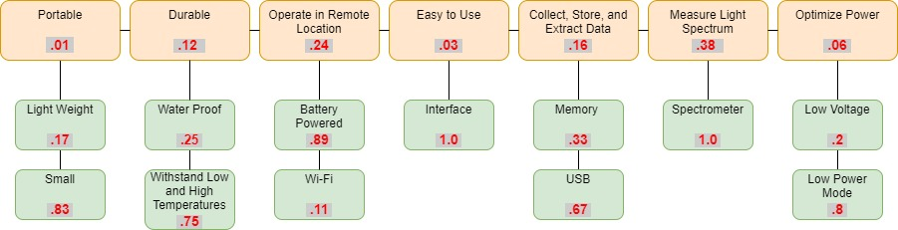

The objective tree illustrates the marketing requirements for the project, with red values indicating weights.

pairwise comparisons
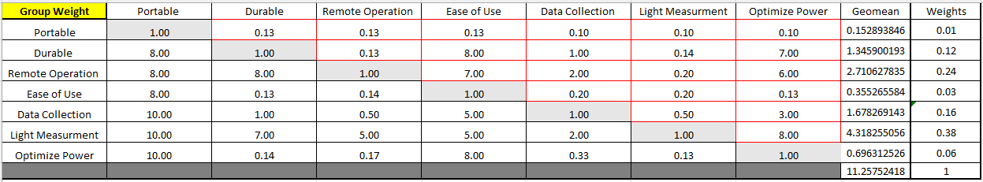

We were able to determine the group weights based off the pairwise comparisons for the marketing requirements. The topics that we considered were portability, durability, remote operation, ease of use, data collection, light measurement, power optimization, and compatibility to the mechanical design. We determined that the highest priority was the ability of the system to measure the light spectrum. The next priority was for the system to be able to function remotely. The third priority was to be able to import and export data. The fourth priority was the durability of the system. Then power optimization, ease of use, and finally portability.
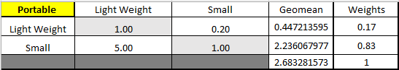

This is the pairwise comparison related to portability. We need the system to be lightweight and small. We determined that having the system be smaller than lightweight was a bigger priority.
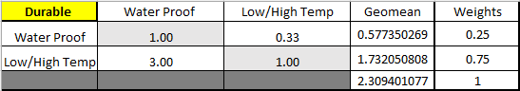

This is the pairwise comparison related to durability. We determined that having the system be able to operate in low and high temperatures was a bigger priority than being waterproof.

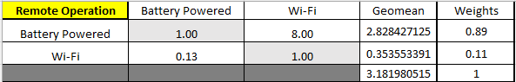In the table above, we were able to compare the topic related to remote operation. The topics we decided to compare are battery-powered and Wi-Fi capabilities. We determined that having the system be battery-powered was a bigger priority than having Wi-Fi capabilities.
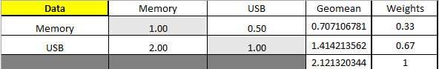

In the table above, we compared the topics related to data storage, collection, and extraction. We needed to decide if removable memory was more beneficial than using a USB port for data. We decided that having a USB port rather than removable memory was a higher priority.
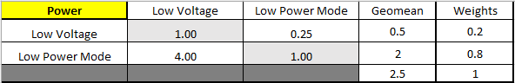In the table above, we compared the topic of power optimization. We needed to decide if using lower voltage was a higher priority than having a low power mode. We determined that having a low-power mode was a higher priority than using low voltage in the system.

expectations
The project aims to aid in the research of forest health. The electrical team will collaborate with the mechanical team to design a remote spectrometer used in harsh conditions. The system is expected to be power-efficient and should be able to capture and store data that can later be retrieved.

Statement of Objectives
[Objective] The objective of this project is to create and test a device capable of assessing the overall health of forests. The device will allow researchers to capture and save spectral image wavelengths that can be used to determine the well-being of plants and trees. With remote data-capturing capabilities, the device will eliminate the need for physical presence during data collection.

System Requirements

Technical and functional requirements
The Spectral Forest SWIR spectrometer will:
- Accurately gather Short Wave Infrared (SWIR) wavelengths from 350 nm to 1000 nm on at least one linear array. *We may potentially extend the spectral range of the unit with additional photo sensors.
- Deliver hyperspectral responsivity in the 350 nm to 1000nm spectrum.
- Provide efficient means for data acquisition, processing, and retrieval.
- Have a microSD card slot for expandable memory capability.
- Connect an externally accessible USB 2.0 port to interface and charge unit without opening the box.
- Design spectrometer electronics to be seamlessly integrated with a custom-tailored PCB.
- Be built into a weatherproof box designed by the ME team.
- Optimize space, footprint, and PCB geometry to integrate into the hermetic enclosure.
- The device will work off-grid, powered by a 12V battery.
- The device will run for as long as possible by incorporating advanced strategies for power conservation.
- Allow for supplemental power when device is deployed on the ground, via detachable solar panel.
- There will be a multi-color LED to indicate functionality, various states of the device, and error conditions.
- Be deployable in a stationary or mobile deployment on the ground, as well as by air attached to an Unmanned Arial Vehicle (UAV) for spectral analysis of the forest canopy and the forest floor.

Hardware, software, and performance requirements
The Spectral Forest SWIR Spectrometer will:
- Run a microcontroller via MicroPython to integrate with the linear array and optimize memory usage as well as power conservation.
- Have custom-designed and ruggedly designed compact PCB to run the MCU and Photonic Integrated Circuit (PIC).
- Run as long as possible off battery power for a minimum of five days.
- Can charge while running.
- Collect supplemental power through a solar panel.
- Be capable of mobile and stationary data collection and processing.
- Log time and date.
- Be able to perform optimally in the full range of weather conditions in Flagstaff and beyond.
- Incorporate additional sensors to log:
  - Humidity.
  - Temperature.
  - Barometric Pressure.
  - Angle of light collection relative to horizon.
- Have controllable sample period.
- Have auto-tunable sample period.
- Allow for controllable duration between samples.
- Allow for ease of data collection with USB 2.0 connection.
- Be programmed with embedded analytics like air density.
- Be calibratable.
- Be accurate and operational within the intended range of functionality.

Engineering trade-off matrix
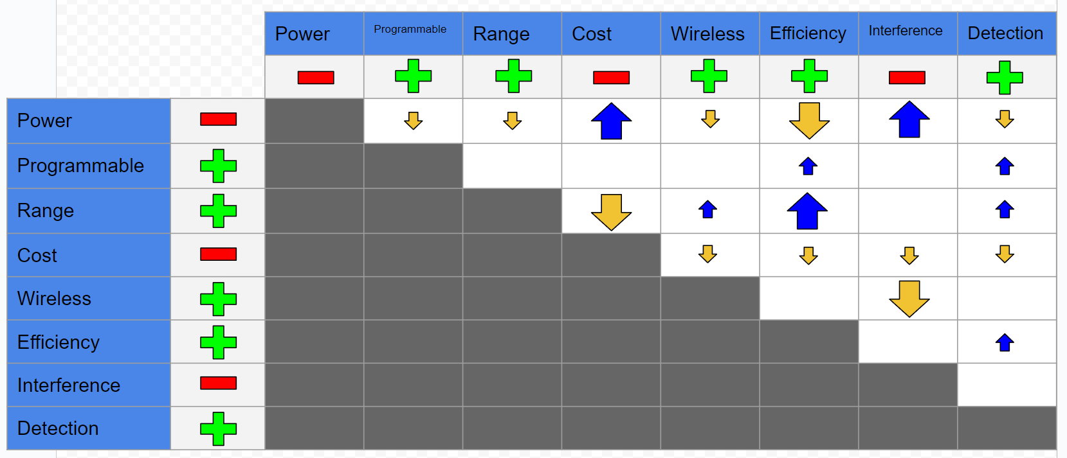The Engineering Requirements compared are relative to how the overall design would be affected by each. Interference refers to both interference of the design of the Mechanical Team (which we want low) as well as the Compatibility of the design with the Mechanical Team (which we want high); Interference was the term used, so the polarity is negative. Low power is generally a restriction to everything but cost and potential electrical interference, while low cost generally isn’t conducive to anything other than low power. A high range chip, programmability, and error detection provided the highest advantage to disadvantage ratio.

Engineering-marketing tradeoff matrix
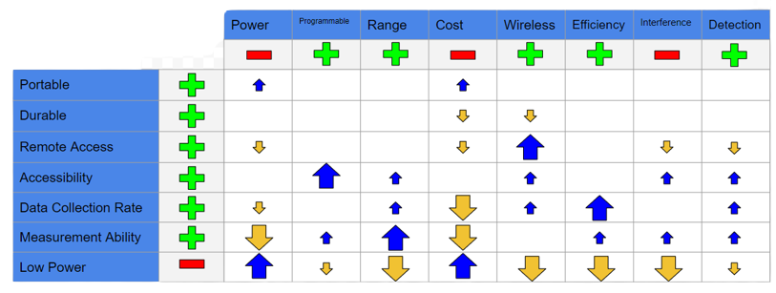Once again, low power caused the most restrictions of any other requirement. Measurement Ability and Range went hand in hand with each other. Based upon the comparison, Accessibility appears to coincide the most with the engineering requirements. None of the marketing requirements seem to provide too many issues, other than low power and, to an extent, measurement ability (the ability to measure the visible light spectrum and beyond).

Benchmark comparing existing options
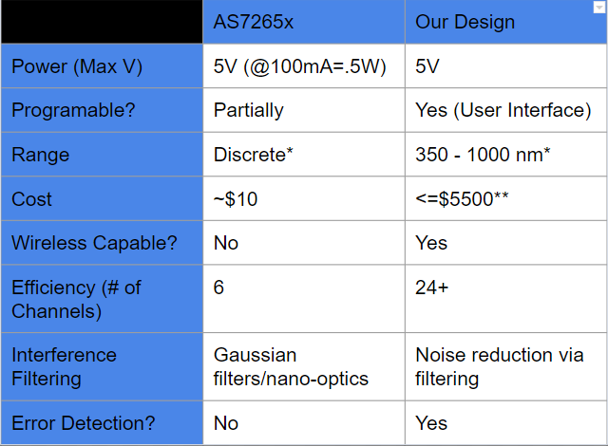
For our benchmarking, there are currently not many commercial devices that can be directly compared in having the same function, so comparison is tested against a hobbyist board that we were initially provided with. We plan to implement smoother, more accurate results alongside hyperspectral readings, an accessible user interface, and wireless communications, at the expense of a higher cost. The AS7265x has a “partial” communication due to having configurable current.
*This is the minimum range. We may expand this range further. The AS7265x chips measure discretely in that it can only detect select wavelengths of light.
**The cost is not final. We obtained potential funding from elsewhere, but the cost cannot exceed this amount.

House-of-quality
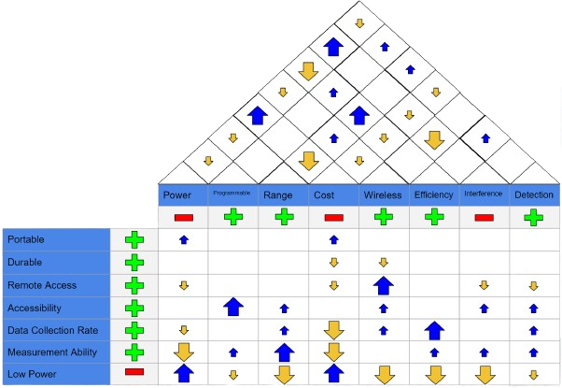
The House of Quality is the merger of the two above tradeoff graphs. All information in said graphs holds true here as well. Blank spaces indicate no correlation.

